Scenario 1:
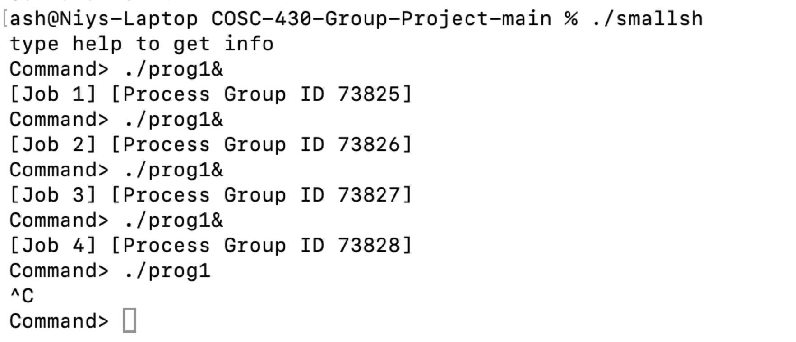
Scenario 2:
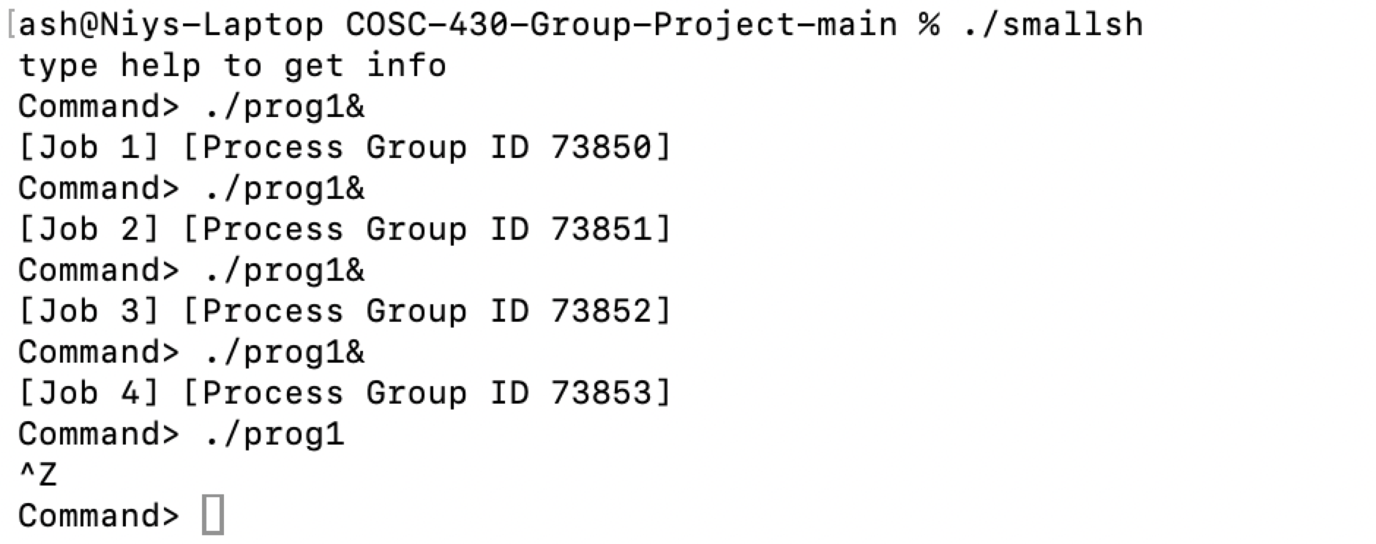
Scenario 3:
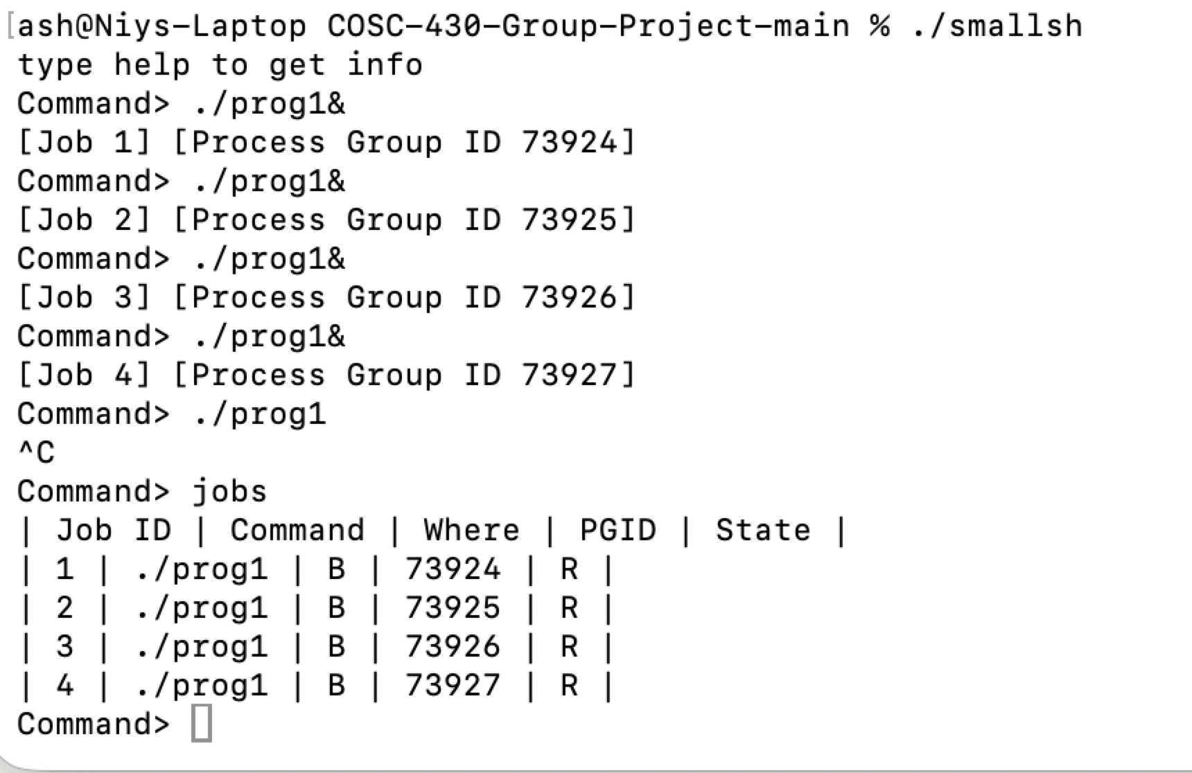
Scenario 4:
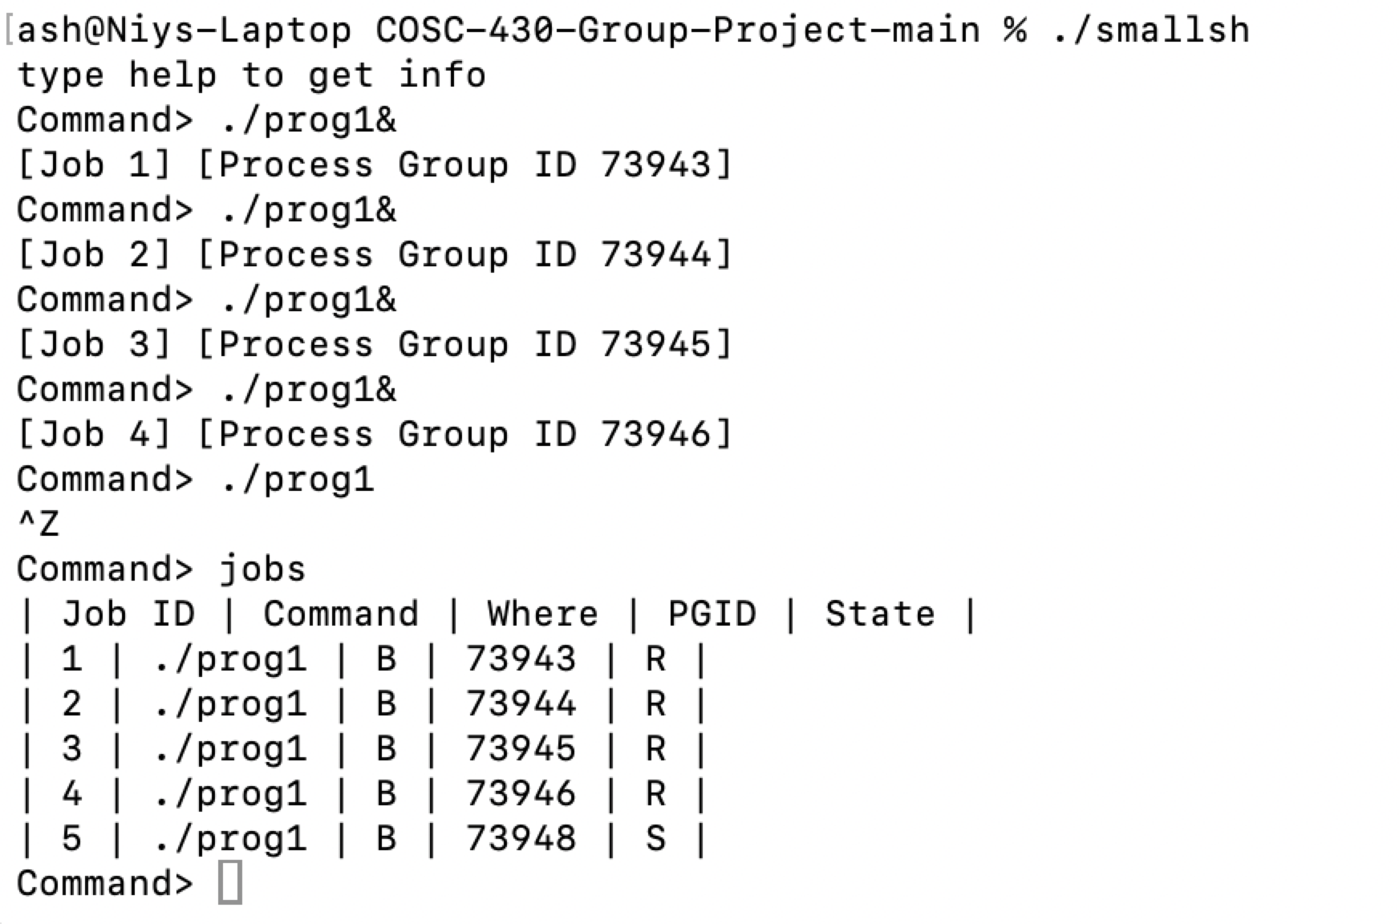
Scenario 5:
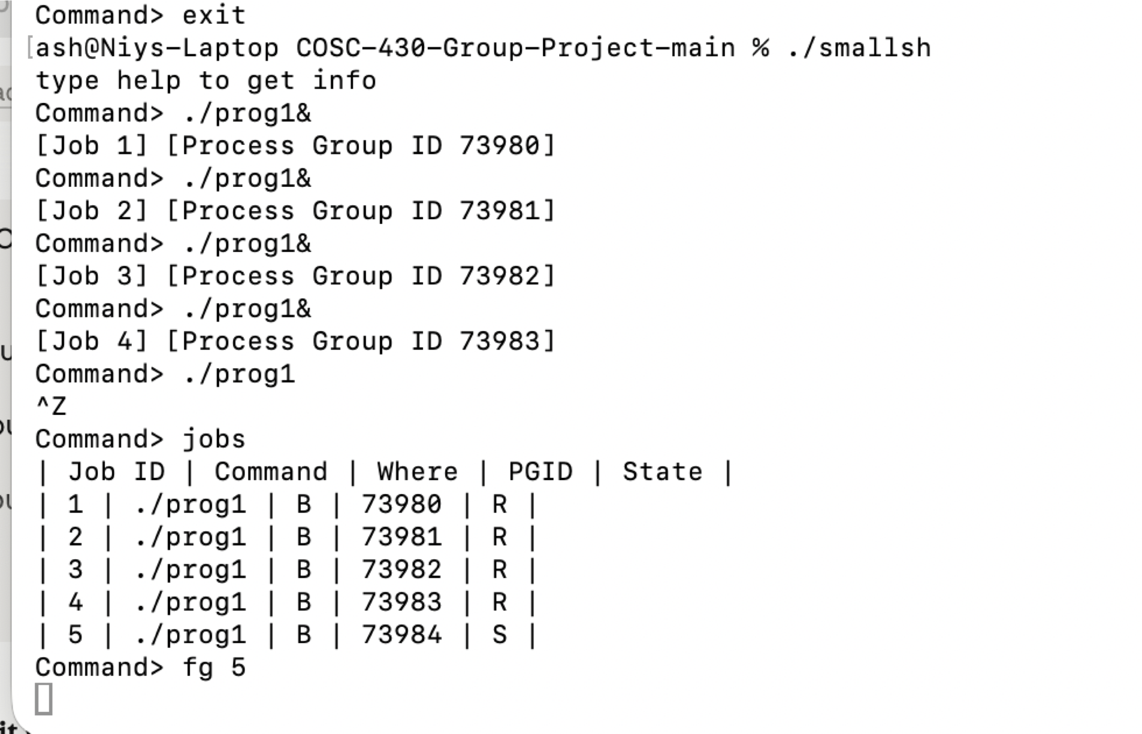
Scenario 6: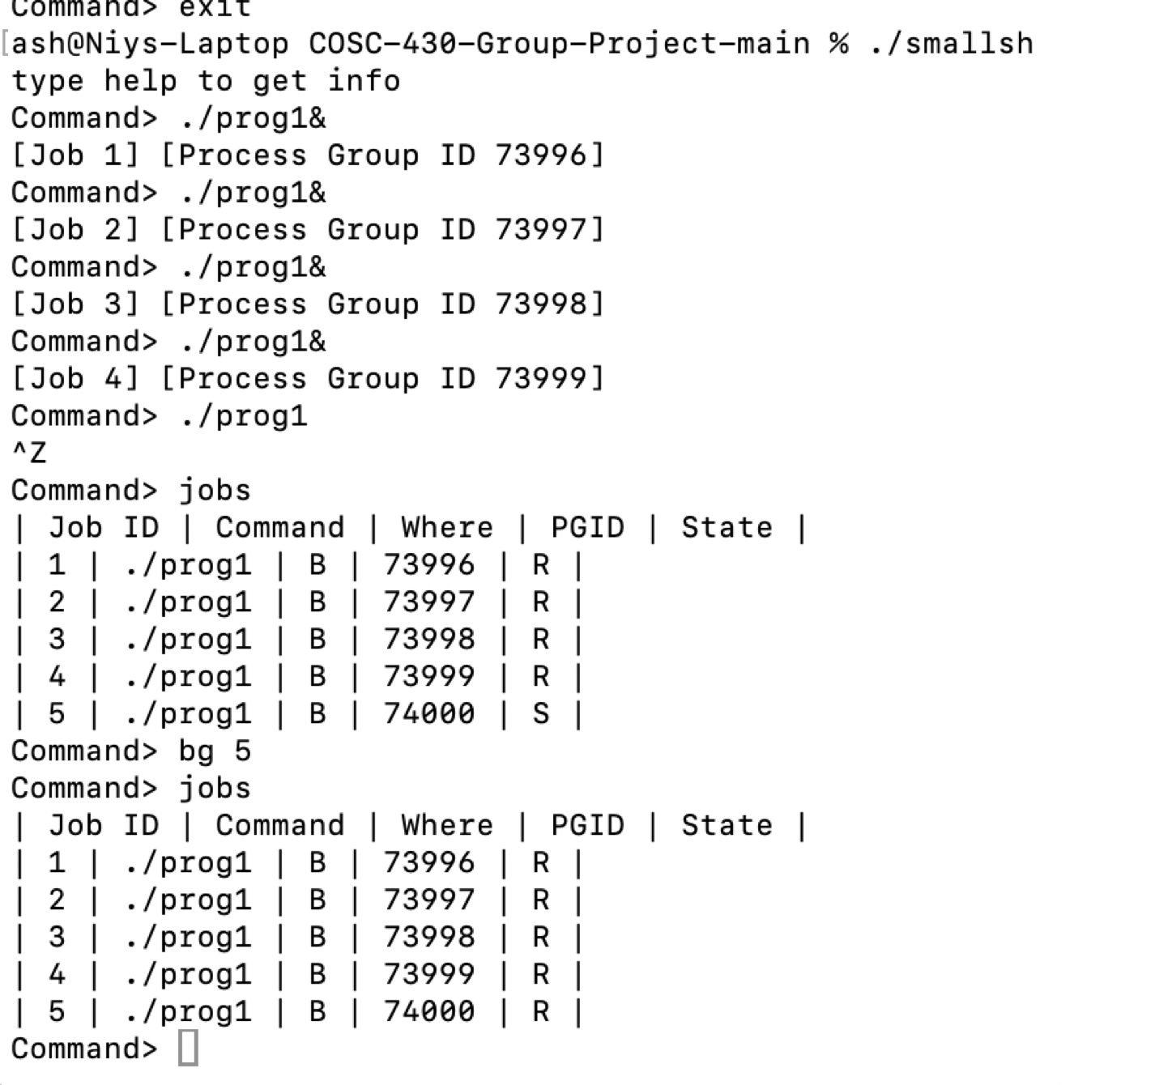
Note: In my output, the foreground stopped job is listed as Job 5, so I used fg 5 and bg 5 instead of fg 3/bg 3

GitHub: https://github.com/h-reyes/COSC-430-Group-Project

